Peer-graded Assignment: Customer Scatterplot

Submit by Mar 30, 12:59 PM +06

**Important Information**

It is especially important to submit this assignment before the deadline, Mar 30, 12:59 PM +06, because it must be graded by others. If you submit late, there may not be enough classmates around to review your work. This makes it difficult - and in some cases, impossible - to produce a grade. Submit on time to avoid these risks.

i

It looks like this is your first peer-graded assignment.  Learn more

1. [**Instructions**](https://www.coursera.org/learn/dataviz-visual-analytics/peer/e8vVx/customer-scatterplot)
2. [**My submission**](https://www.coursera.org/learn/dataviz-visual-analytics/peer/e8vVx/customer-scatterplot/submit)
3. [**Discussions**](https://www.coursera.org/learn/dataviz-visual-analytics/peer/e8vVx/customer-scatterplot/discussions)

Your company has tasked you with analyzing your customer’s purchases and how much the company is profiting from each customer. Your task is to create a scatter plot showing Customer Sales versus Customer Profit. Furthermore, you will need to colorize your scatter plot by Profit Ratio, size your circles by Discount, add the customer’s name to the Tooltip, add a trend line, and add Order date, Segment, and Category to the filter.

[Sales Superstore Dataset.xlsx](https://d3c33hcgiwev3.cloudfront.net/_d0bc89b48dad82128b74950a8d7775ef_Sales-Superstore-Dataset.xlsx?Expires=1585353600&Signature=CmSjFTIhUlkGSvGxOSOfesxfsh4aU6m6n29p8dtbL3BYUq5~kdf3J2cagOYfp-u3KMcjsoE-HBcRkljMHBYFa2MpwxSvHPjS~Z8v6cYAXLYQeiP4we3OZhYt7ekEs54PdA6A9g~GworqYnqphZD8lgEH11I5NGcB2776iFiLgpY_&Key-Pair-Id=APKAJLTNE6QMUY6HBC5A)

**Review criterialess**

The variables you will need to use to complete the task are:

* Sales
* Profit
* Profit Ratio
* Discount
* Order Date
* Segment
* Category
* Customer Name
* Region

Here is what you are trying to replicate:

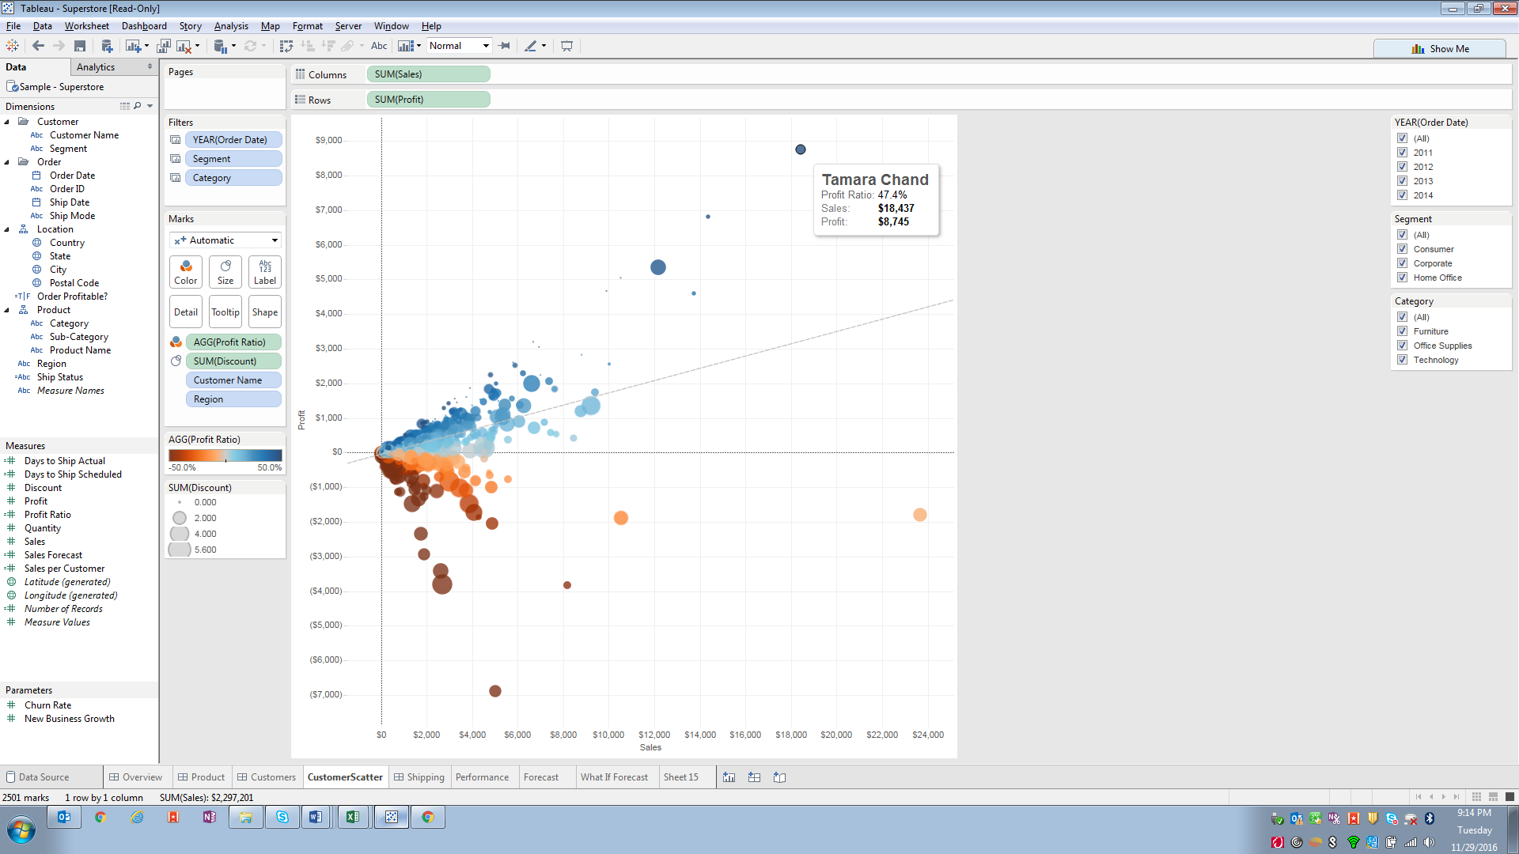

Answer:

